It is Drake’s Kiki Who Loves You (not Keke)
Were you hoping that Keke loved you? Just under half of the US agrees with you.
Press enter or click to view image in full size
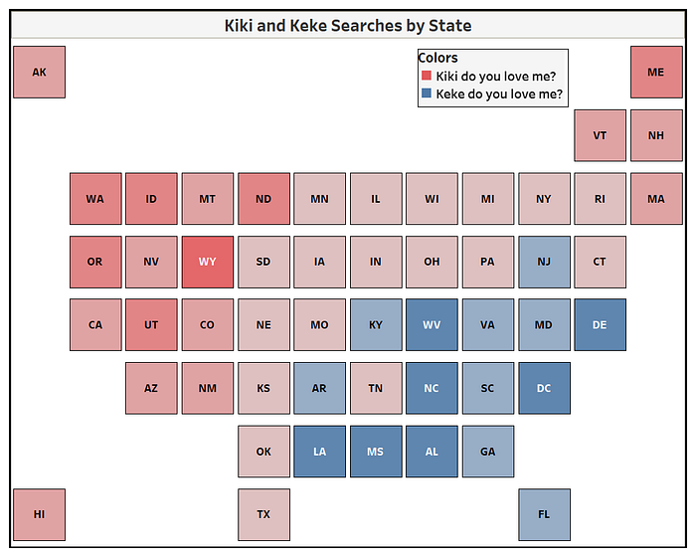
Visualization by Shelby Temple (me) | Data from Google Trends | Made with Tableau Public
What is even more interesting is how the usage of Kiki and Keke are regional. Northwest favors Kiki and Southeast favors Keke. Reminds me of the usage of soda, pop, and coke where the usage changes from one region to another.
Shortly after Drake’s hit album Scorpion dropped. The infectious lyrics from the song, “In My Feelings” inspired the latest viral internet fad #InMyFeelingsChallenge. As most are familiar, the challenge usually included dancing outside of a moving car.
The In My Feelings Challenge joined the all time list of top viral internet fads such as the Ice Bucket Challenge, Mannequin Challenge, and Tide Pod Challenge. What is unique and often dangerous about these fads is they inspire copy-cat video uploads that try to one-up each other for the sake of internet fame.
In the peak of the #InMyFeelingsChallenge craze, I couldn’t help but notice that it had branched out to #KekeChallenge and #KikiChallenge.
This made me wonder, which one is it supposed to be?
Press enter or click to view image in full size
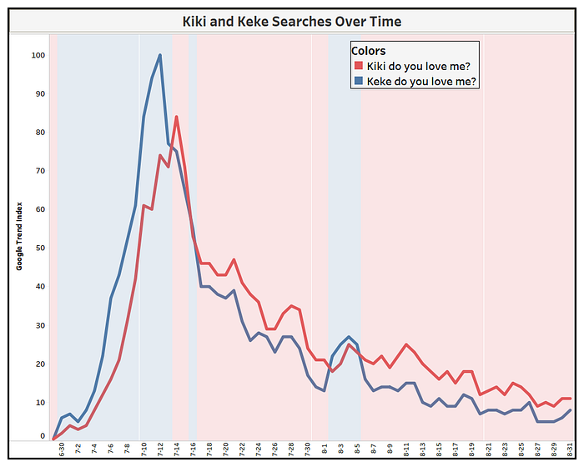
Visualization by Shelby Temple (me) | Data from Google Trends | Made with Tableau Public
Based on Google Trends, Keke was the leader initially and had the highest share at any one time (reaching a Google Trend Index rank of 100). However, Kiki took over starting July 14th, and has been a more popular search term moving forward.
Over this time period, Kiki’s share of search volume is greater than Keke 53% to 47%.
Press enter or click to view image in full size
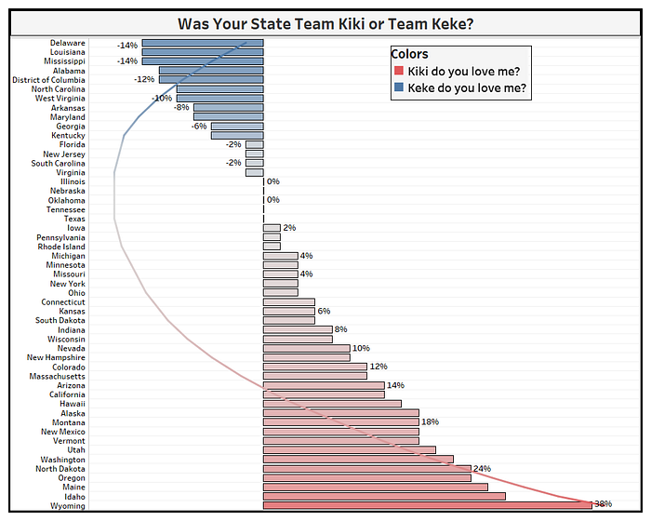
Visualization by Shelby Temple (me) | Data from Google Trends | Made with Tableau Public
If this was a presidential election it would still probably come down to a coin flip… I mean recount… So don’t be ashamed to use one or the other!
Tableau Public Profile

